**Reflections**

**INTUITIVE GUIDANCE**

**with FANG YI**

**Inspirational Guide, Mentor & Analyst.**

[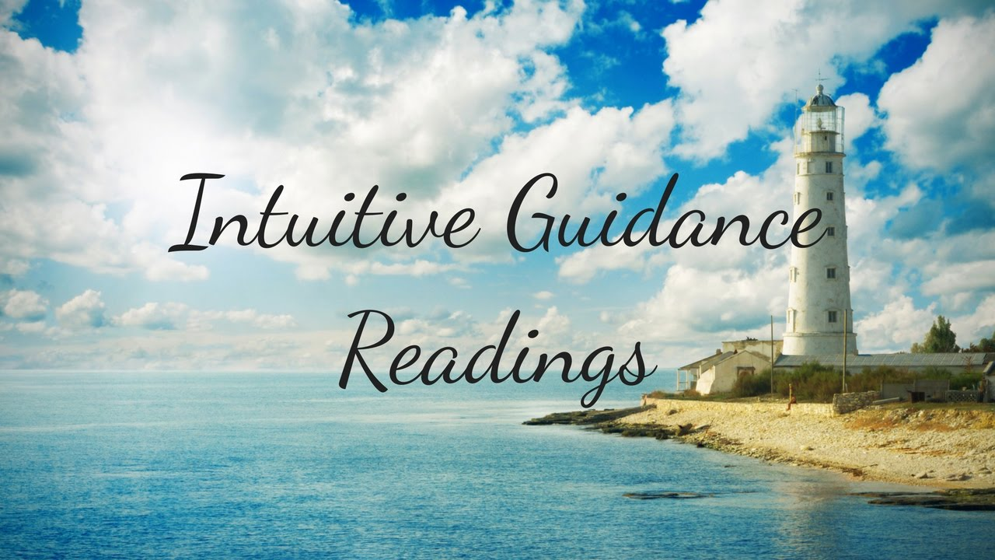](https://www.youtube.com/watch?v=8lX1E2CXi_o)

**November 2 – November 4, 2018**

**Fang Yi** is an Inspirational Guide, Mentor and Analyst who provides emotional, psychic and practical insight and advice into an individual’s life, setbacks and problems. She provides such support through expertise in Angel Miracles Psychic Counselling, Auset Past Life Soul Healing, Auset Sleep Temple Therapy with aromatherapy and essential oils, Hypnotherapy for the resolution of Internal Conflicts, Doubts, Fears and Uncertainties.

Fang Yi has 12 years of corporate training with internationally recognised accounting firms, and 6 years of training in private consults. She had worked and lived in Hong Kong for 5 years from 2007 to 2012 and is now based in Kuala Lumpur.

**SERVICES**

**Oracle Readings HK$800 for 1-hr session**

Harnessing Intuition and Channeling is sometimes tricky because a person may get confused between what is the "Noise" and what really is useful information. Through the use of Oracle Cards designed lovingly and with positive intentions, Fang Yi uses the Oracle Cards as a sort of a safe "Container" that helps to filter through the noise and shine light upon the discussion. The Oracle Card enable the clients to focus better on what needs to be reviewed or contemplated upon at this time for learning and growth.

**Bazi 八字 HK$1000 for 1-hr session**

[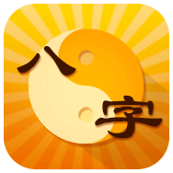](http://m.life.httpcn.com/zt/bazi/)

Bazi (translated literally as Eight Characters in Chinese) denotes the date and time markers used by the ancient Chinese mystics to decode insightful patterns observed over long periods of time. These patterns relate to topics important to existential wellness such as personal character traits, affairs of health, business, family, etc.

There is always something mystical about the information encoded inside our Date and Time of Birth, the exact moment we came into being in this world. Not all will choose to tap into it but for those who do, the intention to know and the act of asking itself opens the Doorways to this mystery.

Through analysing the chart, one is able to observe inherent information in one's Natal chart, as well as the flow of conditions that come and go in one's life, whether it is by decade, annually, monthly, or even daily. This is like charting a map. It is not to judge whether or not it is a good path or bad, but rather, to know the lay of the land more clearly - so that we can make conscious choices as we navigate our way along this journey called Life.

Sometimes the reading and analysis of the chart on the past can be useful in healing from past events that are still bothering the individual. Through analysis of the conditions that existed at that time, one gains insight about the true nature of what transpired. It would make it easier to let go of what once was, and to see the lesson or gift that was bestowed upon us through that experience.

**To book a private session with Fang Yi, please call Reflections on 2504 1333 and / or whatsapp Ruby T Ong 9401 4713**